Institute ‘’Pilla’’
goes green

‘’The world is a beautiful place and we must fight for it.’’
- Albert Einstein
Help the environment,
go green!
We, students of Institute ‘’Pilla’’ in Campobasso, are aiming at fighting to save our planet.
We would like to act on the following points
- to use renewable energies where possible;
- to project and to create a green area in our school;
- to reduce and to sort our school waste.
We planned a photovoltaic system with 28 panels to put on the roof of the greenhouse of our Agriculture Institute to reduce emissions and pollution. First, we calculated our greenhouse consumption, choosing some panels with modules with peak power of 255W.

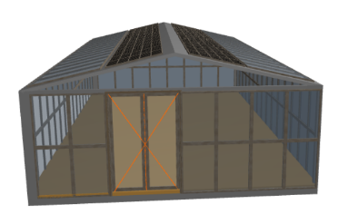

Next to the greenhouse we have created of the area with other plants.
Another idea is to replace fluorescent light bulbs with LEDS. These allow an energy saving of about 85%, since they are eco-friendly and their life cycle can exceed 20 years.
The last point we are focusing on is waste sorting.

Through a survey we got to know how much and which are the consumptions of each classroom, then we will put two bins in every classroom for waste sorting: the first one for paper and the other one for general wastes.

